**KING OF SWEETS**

**BUSINESS PROPOSAL**



**Submitted by:**

Mark John P. Idio

BSIT-WMA: W41

*Bachelor of Science in Information Technology with*

*specialization in Web and Mobile Application*

1. **Rationale and Background**

* **Business Title:** King of Sweets
* **Brief History**

King of Sweets is a coffee shop with different variety of pastries, this coffee shop was opened to the public in May 20, 2020 in City of San Jose Del Monte, Bulacan by Mr. Mark John Peralta Idio. He is a graduate of Bachelor of Science in Information Technology with specialization in Web and Mobile Application, which he used his skills and knowledge in developing a mobile application to automate the order of the customers. This coffee shop is more high-tech than any other coffee shop in the Philippines.

* **Major Objective**

To serve different variety of pastries that will satisfy the cravings of the people.

* **Specific Objectives**
* To provide employment to my countrymen
* To expand the business in the Philippines
* To become the most high-tech coffee shop in the Philippines
* **Vision**

To become the number 1 and high-tech coffee shop in the Philippines with affordable prices, which will lead the business to become successful and open many branches around the world.

* **Mission**

To provide affordable pastries to the customers and comfortable environment that will let them feel that there just in their home.

* 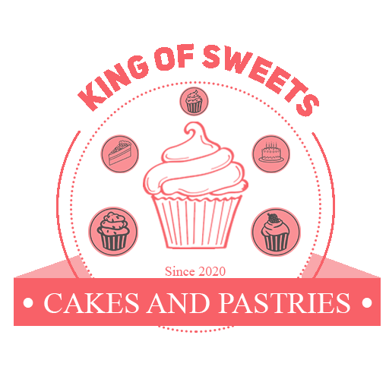**Business Logo**

*Figure 1. King of Sweets Logo*

1. **Factors of Production**

* **Capital**
  1. Financial Plan

|  |  |  |  |
| --- | --- | --- | --- |
| **ITEM** | **QTY** | **PRICE** | **TOTAL** |
| 26 cm Silicone Brush Oil | **1** | **464.00** | **464.00** |
| Baking Cooking Utensils with measuring cup | **1** | **796.00** | **796.00** |
| Baking Utensil Carving Cake | **1** | **905.00** | **905.00** |
| 4-layer cupcake stand | **1** | **607.00** | **607.00** |
| CCTV WIFI IP Camera | **1** | **1,005.00** | **1,005.00** |
| Stainless Table with 2 Chairs | **52** | **5,599.00** | **27,995.00** |
| Drinking Glasses | **10** | **150.00** | **1,500.00** |
| Coffee Mug | **10** | **175.00** | **1,750.00** |
| Table Top Chiller | **1** | **35,000.00** | **35,000.00** |
| Worker’s wages | **12 mos.** | **500.00** | **120,000.00** |
| Supplies and Ingredients Needed | **12 mos.** | **2,876.00** | **34,512.00** |
| Electric Bill | **12 mos.** | **2,700.00** | **32,400.00** |
| Water Bill | **12 mos.** | **2,500.00** | **30,000.00** |
| Air Conditioner | **1** | **8,116.00** | **8,116.00** |
| [LHR HSP85 Ultra-thin One Button Erase 8.5 inch LCD Writing Tablet (Black)](http://www.lazada.com.ph/lhr-hsp85-ultra-thin-one-button-erase-85-inch-lcd-writing-tabletblack-9982643.html?ff=1&sc=EQAU) | **5** | **990.00** | **4,950.00** |
| **TOTAL** | | | **300,000.00** |

* 1. 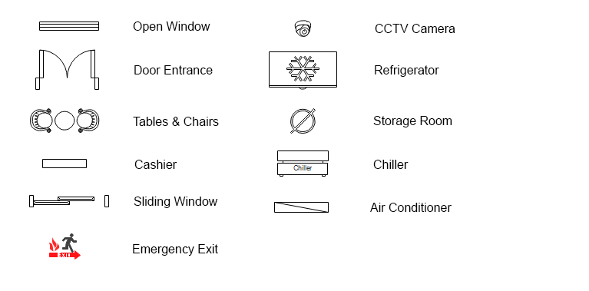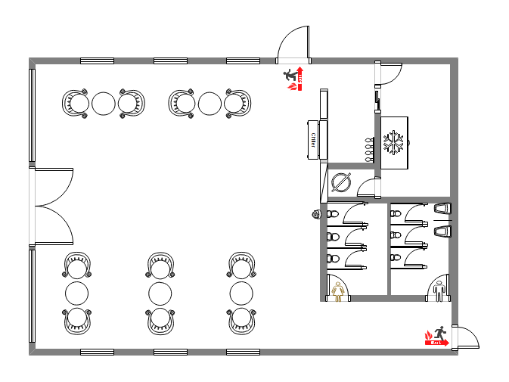Floor Plan

**FLOOR PLAN LEGEND**

* **Entrepreneur**

King of sweets will be managed by Mr. Mark John P. Idio who founded the business. Mr. Idio will be hands-on to the business to monitor the income that is being generated every month and also to manage the business properly since his family is a business-oriented that he could ask for some advices to make the business successful.

* **Land**

The King of Sweets is located at the center of Sapang Palay Market in San Jose Del Monte, Bulacan. The space is free because it owned by the family of the founder, Mr. Mark John Idio. It is ideal to place the shop in the market since everyday there are a lot of people going there to buy their necessities. Visiting the King of Sweets will let them relax after buying in the market.

* **Labor**

The owner will not just finance the business but also he will play major roles of the business such as the cashier and the general manager of the business, King of Sweet will only hire one pastry chef that will make different variety of pastries that the shop will offer to its customers. Since there will be tablets will be used to order, there will be no waiters needed to serve the orders to the customers. They will just use the application installed in the tablet, the cashier will alert the tablet when their order is ready for pick-up at the counter.

1. **Product / Services Offered**

* **Product / Service Description**

Different variety of pastries and coffee will be served to the customers at a cheaper price. Since the business will also have a website, they will be accepting a made to order products, such as cakes and cupcakes and it will be ready to pick-up at the shop. The owner of the business will ensure the cleanliness of the shop and the food being served to their customers.

* **Raw Materials / Components**

These are the following ingredients used by the business; For Cakes and Cupcakes, All-purpose Flour, Eggs, Baking Powder, Sugar, Salt, Food Coloring, Food Flavoring, Whole Milk, Vanilla Extract, Water (as base) and Yeast. For Coffee, Flavored Coffee, Sugar, Milk, and Brewed Coffee.

* **Unique or Distinct Characteristic**

King of Sweets aims to produce delicious and unique pastries to gain loyal customers that will make them invite their family and friends. There will be different flavors and design that will surely attract the customers to buy the products. Since there’s a made-to-order products, designs that the customers made will be made same as what they expected. The customers will use an application to get their order, the application will show different variety of pastries and coffee that the customer will surely love. Once there are done, the order will be processed and the cashier will alert the tablet if their order is ready for pick-up and they will pay their order at the counter.

* **Target Market / Consumers**

The primary target of the business are those people who are tired and want to relax after buying in the market. Of course the target consumers will be also the students who wants to have a coffee break and an environment where they can do their projects or assignments peacefully while enjoying their coffee and sweets.

1. **Sales / Marketing Strategies**

* **How to market the product?**

Strategy to market the product is to meet the mission of the business, which is provide an affordable variety of pastry without compensating the quality of the products. There will be also a discount for senior citizens who will be able to present their valid ID at the counter. Also discount cards will be offered to the loyal customer, they will just have to present it at the counter to earn

points that they can use in their next transaction. Once they reached the points required, they have a discount in any pastry that they want.

* **Advertisement**

It is important that the business should be advertise, the owner of King of Sweets will use the social media platforms to advertise his business, posting on Facebook, Twitter and Instagram will help the business to be known by the future customers. The owner will also ask help from his friends to advertise business in their family and neighbors. The personalized website of the business may also use to promote the products that is being offered.

* **Partnership**

The owner of King of Sweets, Mr. Idio is open for partnership who are interested to invest and help him to manage the business. Partnership will help the business to have more capital which will produce more products that the customers will surely love. Interested partners will just sent an email to Mr. Idio to set an appointment and talk about the partnership agreements.

1. **Future of the Business**

* **Expansion Strategy**

Since the owner is open for partnership, it will help the business to expand and have more products to produce that the customer will surely love. The more products that the shop can produce, the more the income that the shop could generate. After the business generate good income, the shop will undergo a small and quick renovation to expand the lot area of the shop to cater more customers.

* **Increase of Production**

After the expansion of the lot area, the owner and his business partner will start looking for one more pastry chef that will help the existing pastry chef to produce new variety of pastries and it will be the new favorite of their loyal customers. Different flavors of coffees will also be added in the menu. New equipment will be bought to increase the number of production of the pastry chefs.

* **Franchising**

Franchising of the business will begin after 5 years of operation, which was decided by the owner and the business partners. There will be a contract that is signed by the owner, business partners, and the businessman who wish to franchise the business. Products that will be used by the franchised shop will be coming from the same supplier of the original King of Sweets this is to ensure that the taste and quality of product will be the same as the taste and quality of the original products.

* **Contingency Measure / Strategies**

The owner decided to allot the 10% of the monthly income to the unexpected cases, such as fixing of air conditioner, comfort rooms and CCTV cameras.